Damming Rivers
When a dam is constructed, be it for hydropower or water supply, the destruction is highly visible. But the environmental impacts of a dam stretch much further downstream than the location of the actual dam site.
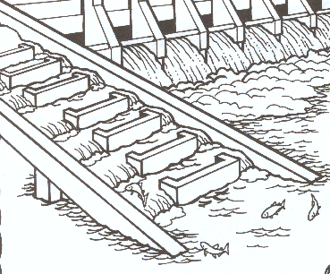
Dams block migratory fish species from their spawning and feeding sites.
Fish ladders have been successful to some extent for species such as salmon. But they are not always effective and are not a viable solution for many tropical rivers.

Dams disturb natural fluctuations in water flow.
This can be particularly damaging in seasonal floodplains, affecting deposits of nutrients as well as the lifecycles of species that depend on these fluctuations for feeding and breeding grounds. Dams change daily flows by releasing water as a reaction to human demands, like energy and irrigation, instead of as nature intended.

Water quality can be degraded.
Reductions in water quantities can increase salinity and make the water unusable for drinking and irrigation. Decomposition of organic matter and the leaching of mercury from the soil can introduce toxins.

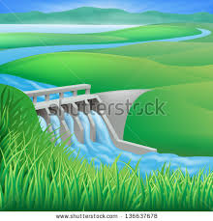
The transport of sediment along the river is disrupted.
This affects the morphology of the riverbed, downstream floodplains, and even coastal deltas. In turn, this can:
• increase flood risk
• hamper navigation
• lower groundwater tables
• cause an accumulation of toxic materials
• affect entire ecosystems.
- The build up of sedimentation in the reservoir also reduces the dam's capacity and operational lifetime.
List at least 4 reasons damming a river causes problems for the environment

