Economic Systems
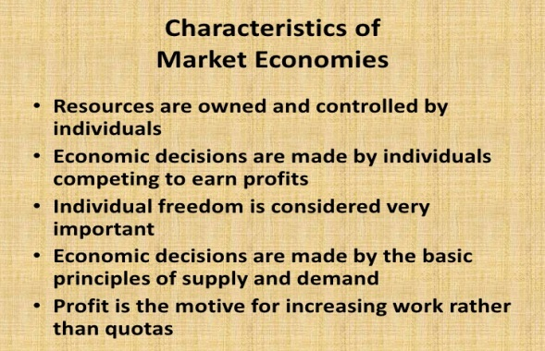
In a market economy, consumers and businesses decide what they want to produce and purchase in the marketplace. They make these decisions by “voting with their dollars.” Producers decide what to produce given the demand they see in the marketplace in terms of their sales and the prices they get for their goods and services. In a pure market economy, also known as a laissez-faire economy (from the French “allow to do”), the government plays a very limited role in what is produced. The government does not direct, and may even lack the power to direct, the private sector to produce certain goods and services.

Who decides:  What to produce? | Who decides:  How to produce? | Who decides:  Who gets what?
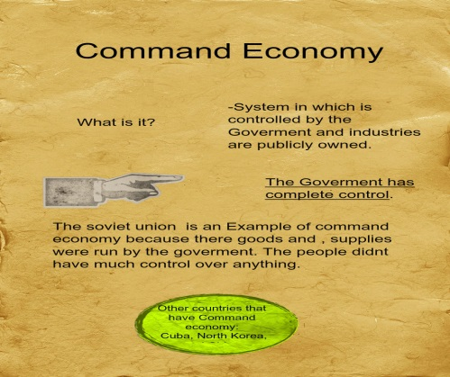
In a command economy, also known as a planned economy, the government largely determines what is produced and in what amounts. It directs producers to make and deliver goods and services in specified amounts. In practice, command economies are associated with socialism and communism, two closely related forms of government. Socialism and communism are characterized by collective ownership of the means of production and central planning functions that try to produce what people want and need, in the quantities and at the time required.
In command economies, the people (in the form of the state) own the means of production. The state, which is seen to embody the will of the people, decides what will be produced according to a plan based upon what the state calculates to be people's need and desire for various goods and services. The state also plays an important role in determining how goods and services are distributed, that is, in deciding who gets how much of what.
Who decides:  What to produce? | Who decides:  How to produce? | Who decides:  Who gets what?
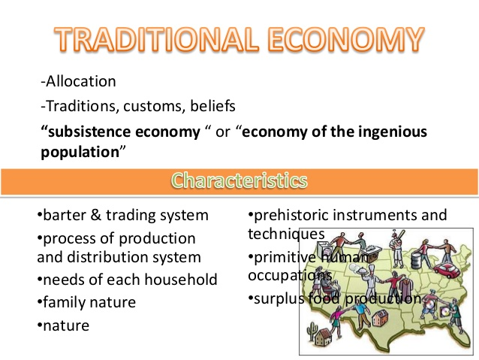
A traditional economy is a system where traditions, customs, and beliefs shape the goods and products the society creates. Countries that use this type of economic system are often rural and farm-based. Also known as a subsistence economy, a traditional economy is defined by bartering and trading. Little surplus is produced, and if any excess goods are made, they are typically given to a ruling authority or landowner.
Hunting, gathering, and cultivation are the main tasks for workers in a traditional economy. There are big parts of the world's population that still work in traditional economies, primarily in third-world countries with larger indigenous populations. Underdeveloped areas of South America, Africa, and Asia still rely on this type of economy for survival.
In many cases, a traditional economy may have no official currency whatsoever, with any available wealth going to the upper classes. As neighboring countries and influences permeate a traditional economy, the economic system can morph into a mixed, command, or market economy. In command economies, prices and supplies are determined by the government, while, in contrast, prices in a market economy are set by supply and demand. A mixed economy includes both private enterprise and some degree of government control.
Who decides:  What to produce? | Who decides:  How to produce? | Who decides:  Who gets what?

